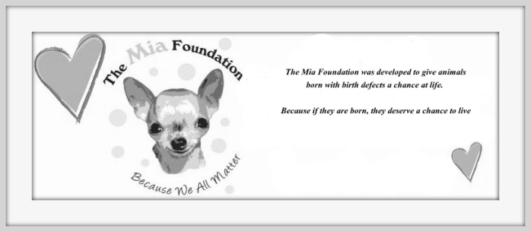
The Mia Foundation
Mia’s Angels Foster/Transport Agreement

Name:_______________________________________________________________________________
Address: _____________________________________________________________________________
City: ___________________________________________State:_________________Zip:_____________
Phone: (Home) _______________________________ (Cell) ____________________________________
E-mail address: ________________________________________________________________________

I, _________________________________________________________, agree to follow all rules set forth in this contract.

1. The foster home agrees to temporarily house and care for the animal(s) belonging to The Mia Foundation. The foster home understands and agrees that The Mia Foundation is the sole and rightful owner of the foster animal(s).
2. The foster home fully agrees and understands that The Mia Foundation will make all decisions regarding this animal and agrees to communicate with a representative on a daily basis via phone or email with updates/questions/concerns on the foster animal.
3. The foster home agrees to provide this animal with proper veterinary care as is recommended by The Mia Foundation and agrees that full reimbursements for veterinary care are only for expenses discussed and agreed upon prior to treatment, and only if the veterinarian used has been approved by the rescue. The foster also understands that many vet appointments may be necessary for a special needs pet and that all appointments must be kept.
4. The foster home understands that The Mia Foundation is not responsible for any damage caused by this animal while in foster care.
5. The foster home agrees that the care of this animal is not transferable. The foster home agrees that, if for any reason the foster home is unable to continue to house and care for the animal, The Mia Foundation will immediately be notified and the foster home agrees to continue caring for the animal until other arrangements can be made and understands this may time several days/weeks.
6. The foster home agrees to provide food, toys, and clean bedding for the foster animal. Only when discussed prior will any reimbursement be made for special food.
7. The foster home agrees that this animal will reside in the home of the foster home, not outside or in a garage/shed/etc. The foster also agrees to never let the animal outside unsupervised.
8. The foster home understands that it is often their job to determine or learn the temperament of the animal they are fostering. The foster home understands that The Mia Foundation has no way of knowing the temperament of most animals coming in to the program. Therefore, the foster home agrees to use due caution when handling the foster animal and will not hold The Mia Foundation responsible for any injuries obtained by the animal.
9. The foster home grants permission for a representative of The Mia Foundation to visit the home at any time to check on the wellbeing of the animal.
10. The foster home agrees that The Mia Foundation cannot predict how long an animal may stay in foster care.
11. The foster home agrees that if asked to return the animal, they need to do so within 24 hours of being asked.
12. The foster home must be available to bring the animal to vet appointments and to also be available to answer questions, provide information, and return emails to potential adopters and to The Mia Foundation representatives in a timely manner.
14. Transporters agree to drive short/long distances to help with animals. Transporters agree to be available for contact during transports via cell phone and also agree to provide leashes and crates for each passenger. Transporters agree that no compensation for gas will be made and also agree to not hold The Mia Foundation responsible for any damages or injuries obtained during a transport.
I have read and understand this entire agreement, and do hereby agree to all the above terms.

_______________________________________________________________ ___________________
Foster/Transporter Date

_______________________________________________________________ ___________________
The Mia Foundation Representative Date

The Mia Foundation 3177 Latta Road #188 Rochester NY 14612
E-mail: Sue@themiafoundation.com Phone: 585-737-6420
WWW.THEMIAFOUNDATION.COM ~ because if they are born, they deserve a chance to live!

